# Archi - ArchiMate Modelling



**What’s New in Archi Version 2.3.1**

# Important Note

It is always a good idea to make backup copies of your data before installing a new version of Archi. Whilst we make every effort to test the software and check for bugs we cannot guarantee that bugs do not exist in the application nor that your data might be affected by changes in this version of Archi.

Please backup your data first!

## New Features in version 2.3.1

* Built on Eclipse 3.8 RCP
* Support for Java 7
* Support for Windows 8 32-bit and 64-bit versions
* Improved native launcher for Mac OS X version
* Added "Archi on the Web" menu item to Help menu
* The Java version shipped with the Windows installer is now version 1.6.0_34

## Fixes in version 2.3.1

* Fix hyperlinks not working in some Operating Systems in Properties window's multi-line text controls
* Internal bug fixes
* View Full Screen removed from Mac OS X version as it now conflicts with Mac's own Full Screen support

## New Features in version 2.3

* Improved UI performance when there are many tree nodes open in the Models Tree
* Can now connect lines between View reference figures and other figures
* Double-click in blank area of User Properties Table creates new Property
* The background for a Sketch view can now be set per view to one of "None", "Brown Paper" or "Cork" from the "Appearance" tab in Properties
* The Java version shipped with the Windows installer is now version 1.6.0_31

## Fixes in version 2.3

* Fix Magic Connector sometimes not creating connection on Mac
* Fix preferred figure type not used when adding elements from Models Tree to a View

# Review of the Main New Features

## Improved UI performance when there are many tree nodes open in the Models Tree

If you have a lot of very large models open in the Models Tree and showing many tree nodes, UI performance could be very slow when renaming, creating and removing elements. This has now been improved.

## Can now connect lines between View reference figures and other figures

The general connection tool in the palette can now create connections to and from View reference figures. You can also connect Groups to other Groups.

## The background for a Sketch view can now be set per view to one of "None", "Brown Paper" or "Cork" from the "Appearance" tab in Properties

In Preferences you can set the default background to use for a new Sketch View to one of “None”, “Brown Paper”, or “Cork”:

*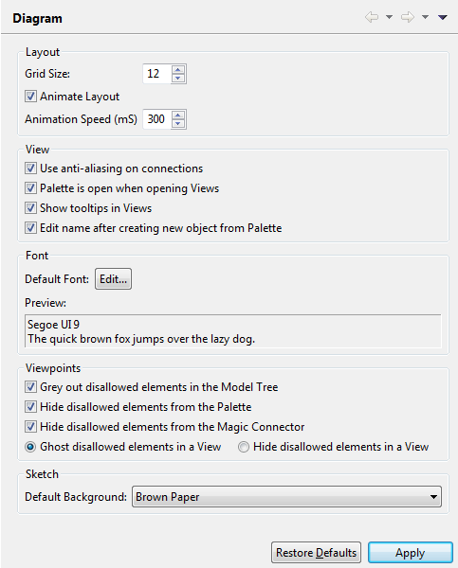  
Diagram Preferences*

And you can also set it individually for each Sketch View in the Properties Window:

*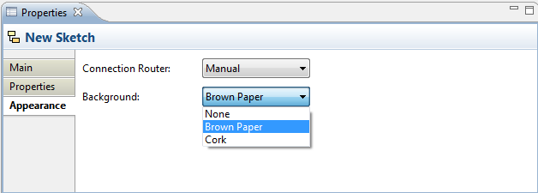  
Sketch View background options*

